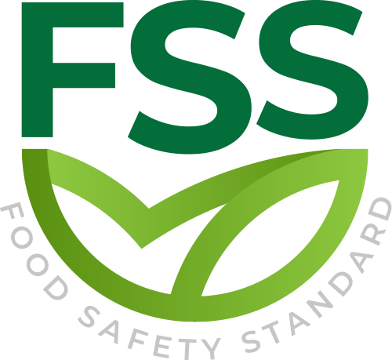

REQUIREMENT FOR AUDITING THE ORGANIZATION STANDARD

Document Code _ FSS-STD-004
Approval Date : 20.02.2020

Title: Food Safety Standard (FSS)
Contact Adress : Merkez Mahallesi Dr Sadık Ahmet Cd, No 38/44 A Bağcılar/İstanbul – Türkiye / Turkey
Contact Mail: info@foodcertificate.org
Website: www.foodcertificate.org
Phone: +90 212 702 40 00

ABOUT US
The Food Safety System (FSS) certification program developed by our organization is a system for the inspection and evaluation of food safety and quality according to accepted standards. The certification program in question not only ensures food safety, but also undertakes responsibilities such as public health and environmental protection. This certification program is recognized as the most important initiative of recent years for a more effective and quality food management.

While developing the Food Safety System (FSS) certification program, our organization followed a global food safety strategy and adopted a safer food policy to be healthier. According to this strategy, preventing foodborne diseases and ensuring food safety require holistic, risk-based and timely food safety policies and strategies.

Our organization continuously improves its effectiveness by participating in the efforts for the development and implementation of the food management system in enterprises. It supports businesses in the food industry to meet legal and regulatory requirements, tries to establish a quality policy in businesses, supports businesses in establishing food safety targets, directs management reviews and tries to ensure the correct and effective availability of resources. In all these works, our organization approaches businesses in an impartial and independent manner and does not enter into any conflict of interest.

Our organization acts with a sense of responsibility in order to be with people who care about their nutrition and to help them make safe food choices. In this context, it provides Food Safety System (FSS) certification services to support companies that produce, store, distribute and prepare food in order to prove their efforts in this direction.

- SCOPE
This section describes the program requirements, according to which the licensed certification body should review the organization's food safety management system (FSMS) or FSMS and quality management system (QMS) to obtain or maintain FSS or FSS quality certification, respectively.
- REQUIREMENTS
The organization shall formulate, implement and maintain all the requirements outlined below, and be audited by a licensed certification body to obtain a valid certificate.
The audit requirements for FSS ;
- ISO 22000 Food Safety Management System
- FSS extra requirements
The audit requirements for FSS-Quality ;
- ISO 22000 Food Safety Management System
- ISO 9001 Quality Management System
- FSS extra requirements

B.1 ISO 9001 and ISO 22000
For FSS-Quality Certification, the requirements for the development, implementation and maintenance of the Quality Management System (QMS) are specified in the ISO 9001:2015 standard "Quality Management System-Requirements".
For FSS and FSS quality certification, the requirements for the development, implementation and maintenance of the food safety management system are stipulated in the ISO 22000 standard "Food Safety Management System-Requirements for any organization in the food industry".

B.2 FSS Additional Requirements
- In addition to Article 7.1.6 of ISO 22000:2018, the organization shall ensure that where laboratory analytical services are used for food safety verification and/or validation, these shall be produced by the ability to accurately use validated test methods and best practices Obtain repeatable test results.
- In addition to Article 8.5.1.3 of ISO 22000:2018, the organization shall ensure that the finished product is marked in accordance with all applicable legal and regulatory requirements of the intended country of sale, including allergens and customer-specific requirements.
- If the product is not labeled, all relevant product information should be provided to ensure that customers or consumers use the food safely.
B.3 Food Safety
The organization shall develop documented procedures to:
- Conduct threat assessment to identify and evaluate potential threats;
- Develop and implement mitigation measures for major threats.
- The organization shall have a documented food defense plan that specifies mitigation measures covering the processes and products within the scope of the organization's Food Safety Management System.
- The food defense plan should be supported by the organization's FSMS.
- The plan should comply with applicable laws and be kept up to date.

B.4 REDUCTION OF FOOD FRAUD
The organization shall develop documented procedures to:
- Conduct food fraud vulnerability assessment to identify and assess potential vulnerabilities;
- Develop and implement mitigation measures for major vulnerabilities.
- The organization shall have a documented food fraud mitigation plan that specifies mitigation measures covering the processes and products within the scope of the organization's Food Safety Management Safety.
- The food fraud mitigation plan should be supported by the organization's Food Safety Management Safety.
- The plan should comply with applicable laws and be kept up to date.
B.5 Allergen Management
The organization shall develop a documented allergen management plan that includes:
- Control measures to reduce or eliminate the risk of cross-contamination and
- The risk assessment covers all potential allergen cross-contamination sources.
B.6 Environment Monitoring
The organization should have:
- A documented procedure for evaluating the effectiveness of all control measures to prevent environmental pollution in the manufacturing environment, which should at least include the evaluation of existing microbial and allergen control measures;
- Monitoring activity data, including regular trend analysis;
- Risk-based environmental monitoring plan.

B.7 Transportation
The organization shall ensure that products are transported and delivered under conditions that minimize the possibility of contamination.
B.8 HACCP
- For food chain category I, the following additional requirements apply to Article 8.5.1.3 of ISO 22000:2018:
The organization should establish specific requirements to prevent packaging from being used to impart or provide food functional effects.

